Google Ads

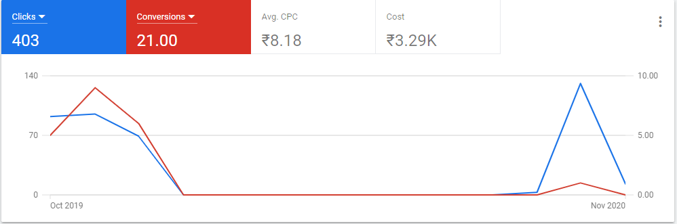

Day And Hour Report of Conversion
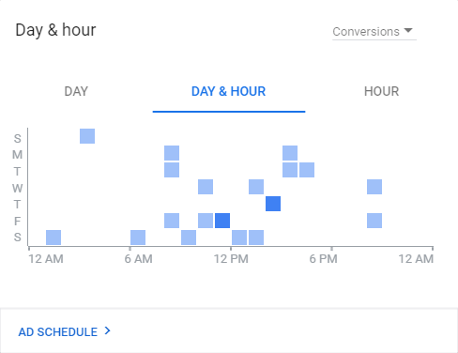

Demographics
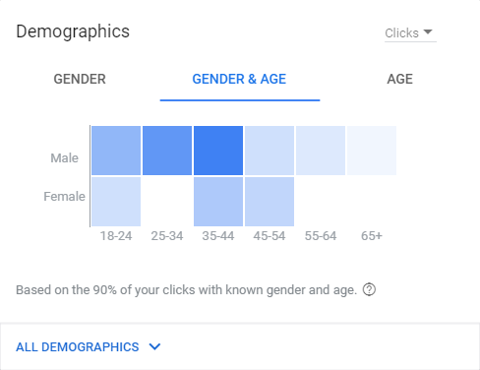

Facebook Ads - Niko Hotels

Amount spend - 94.40(including GST)
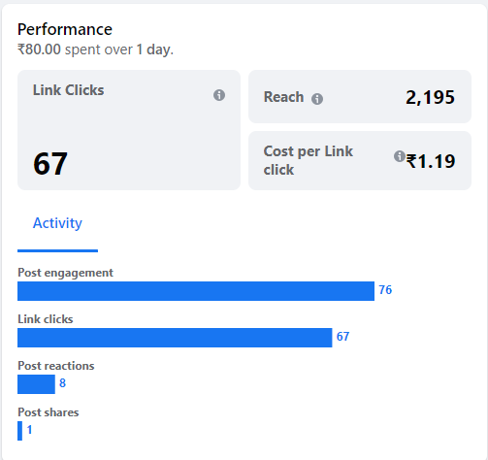

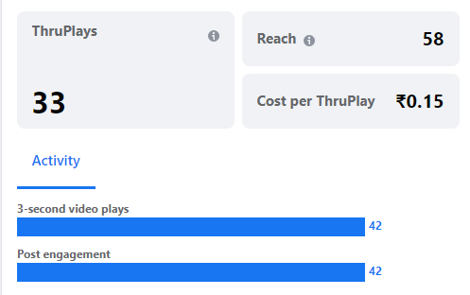

Goal: To improve website traffic with Book Now Button.

Amount Spent: 40 INR a day

People reached - 946

Clicks - 10

Egkerala

Amount Spent on Ad - 350(7 days)

Post Reach - 420

Post Engagement - 418

Thruplays - 385

Total Budget - 413(including tax)

Target location - Japan

